CareSys Register and Agency Test Status 27 October 2026
Status PASS
Prepared for the CareSys project owner. This report records the local registration and platform approval tests for the new in-app notification workflow. The tested scenarios passed, and the disposable account, agency and test alerts were removed after verification.
Validation | Recorded result
Backend suite | 254 tests and 1411 assertions passed
Registration and notification cases | 176 passed
Optional field combinations | All 128 combinations passed
Browser checks | 28 passed
Screenshot evidence | 9 captures embedded in this document
Existing accounts and Stripe | Preserved and unchanged

Registration and approval workflow
1. The agent signs in and registers an agency with the required legal name, country, official email, currency and timezone. Phone numbers, business registration number and address are optional.
2. The agency stays pending. Every active platform administrator receives a review request, and the owner receives a pending-review receipt.
3. The administrator opens the notification, checks the saved agency details and records a verification decision and review basis.
4. The owner receives the matching verified and approved, rejected or suspended message. Reapproval creates a new decision entry.
5. Unread counts appear in the top-right menu. Notifications can be marked read and remain accessible through the personal inbox when agency operations are locked.
Approval verifies the registration. It does not save a card, start a trial, select modules or collect payment. Stripe remained disabled throughout these tests.
Evidence captured for application revision a145914. Report date uses America/Los_Angeles; notification times and browser execution records use UTC.

Backend registration and notification coverage
The dedicated registration suite combines 33 registration variants, 128 optional-field combinations and 15 workflow, permission and consistency cases. The broader regression suite covers the existing application services.
Area | Cases covered | Result
Required registration details | Empty/overlong legal name, missing/malformed official email, malformed/unknown country, currency format/length and invalid timezone | PASS
Optional phones | None, business only, shared mobile/contact, separate mobile/contact, all different numbers, disabled stale input ignored, missing selected values and landline rejected as mobile | PASS
Optional address | US state/ZIP, Canadian province/postal code, UK optional county, UAE without postal code; missing street/city, invalid state and invalid postal format | PASS
Optional combinations | All 32 phone checkbox combinations crossed with address on/off and business registration supplied/omitted: 128 combinations | PASS
Registration persistence | Owner membership, pending verification, awaiting-card billing, normalized contact snapshots and no partial save after invalid input | PASS
Duplicate submissions | Same account/key retries return one agency; changed details rejected; another account cannot reuse the first account's registration | PASS
Notification delivery | Administrator review request, owner pending receipt, approved/rejected/suspended/reapproved decisions, multiple administrators/owners, inactive administrator excluded | PASS
Permission boundaries | Guest access denied, non-operator approval denied, revoked platform role denied, disabled account registration denied, recipient-only reads and current-role filtering | PASS
Consistency and audit | Stale version denied, repeated current decision does not spam alerts, notification-storage failure rolls back registration/approval, UTC creation and read times | PASS
Output safety | Agency markup escaped in notification HTML; unknown or another recipient's reference returns unavailable | PASS
Regression | Existing recruitment, consent, employment, scheduling, multi-agency, billing, invoices, API authentication and database-isolation suites | PASS

Optional field combinations
All 32 combinations of the five phone choices were crossed with address on or off and business registration supplied or omitted. These seven binary choices produce 128 tested combinations. Unselected values were ignored, shared numbers were reused and every successful registration stayed pending.
Country examples include US state and ZIP code, Canadian province and postal code, UK optional county and UAE without a postal code. Phone and address formatting use the installed country metadata libraries.

Browser checks 1 to 14
The browser test used a disposable fictional account and agency on the local HTTPS application. It exercised the owner and administrator in separate browser contexts.
No | Check | Result
1 | Guest cannot read notification menu (HTTP 302) | PASS
2 | Personal account registration succeeds | PASS
3 | New account has empty inbox | PASS
4 | Phone fields hidden until selected | PASS
5 | Address hidden until selected | PASS
6 | Agency registration redirects to billing | PASS
7 | Registration does not enable Stripe or charge | PASS
8 | Notification menu available on locked billing | PASS
9 | Owner receives pending review receipt | PASS
10 | Agency owner cannot access platform review | PASS
11 | Registration retry redirects to same agency | PASS
12 | Administrator receives registration review alert | PASS
13 | Owner cannot mark administrator notification as read (HTTP 404) | PASS
14 | Notification read requires CSRF token (HTTP 403) | PASS

Registration and read controls
The same registration form key returned the original agency on retry. Another account could not read or mark the administrator notification, and missing CSRF protection prevented a read action. Administrator review displayed the saved contact and address information.

Browser checks 15 to 28
The browser test used a disposable fictional account and agency on the local HTTPS application. It exercised the owner and administrator in separate browser contexts.
No | Check | Result
15 | Review shows official contact and address | PASS
16 | Platform decision verified | PASS
17 | Owner receives verified and approved notification | PASS
18 | Owner can mark decision read | PASS
19 | Platform decision rejected | PASS
20 | Notification count updates without page reload | PASS
21 | Rejected status notification is accurate | PASS
22 | Platform decision suspended | PASS
23 | Suspended owner can still view personal notifications | PASS
24 | Suspension restricts agency access | PASS
25 | Platform decision verified | PASS
26 | Approval leaves trial awaiting card | PASS
27 | Mobile notification panel stays below trigger and inside viewport | PASS
28 | Notification menu available on platform policy page | PASS

Decisions and access
Verified, rejected, suspended and reapproved decisions produced distinct messages with review notes. A suspended owner retained access to the personal inbox while agency access was restricted. Approval left billing awaiting card, and the unread count updated without a page reload.

Findings evidence and test scope

Implemented controls
Registration and decision notifications are saved in the same transaction as the business change. Simulated notification storage failures rolled back registration or approval.
Per-form registration protection prevents duplicate agencies and duplicate alerts. Platform role and account status checks reject stale or revoked access.
Notification creation and read times are stored in UTC. The mobile popup remains below its trigger and inside the viewport.
The browser harness follows the existing account-name policy, accepts the correct HTTP 303 redirect and uses desktop sign-out after the mobile layout check.

Cleanup and preserved data
The disposable test account, agency and its notifications were removed after the browser run. Existing account IDs were preserved. No real card setup or payment occurred. The private fixture credential manifest was deleted and is not included in the evidence.

Evidence retained beside this document
File | Purpose
backend-tests.txt | Backend console result
backend-junit.xml | Machine-readable test results
scenario-results.txt | Named test outcomes
test-case-matrix.csv | All 254 backend case results
browser-results.json | 28 browser checks and evidence references
cleanup-results.json | Disposable fixture cleanup verification
screenshots folder | Nine original fictional test captures

Reproduction
Run the backend suite from the CareSys repository with C:/xampp/php/php.exe vendor/phpunit/phpunit/phpunit --no-coverage.
For browser checks, start the local HTTPS servers, set CARESYS_NODE_MODULES to the Playwright package directory and run node tests/Browser/register-agency-notifications.cjs. Then run C:/xampp/php/php.exe tests/Browser/cleanup-register-agency.php. The guarded cleanup removes only its disposable fixture and private manifest. Do not seed or reset existing user accounts.

Scope and limits
These are local in-app tests, not production certification or email, SMS or push delivery. Postal checks validate format rather than deliverability. The 128 optional-choice combinations are exhaustive for the tested flags; arbitrary text and every real-world business arrangement cannot be exhaustively enumerated. The menu shows 10 notifications and the inbox the latest 100 eligible notifications. With no active platform administrator, the registration remains pending and the owner receives a receipt. Existing pending agencies were not retroactively notified.

Empty inbox and administrator notification evidence
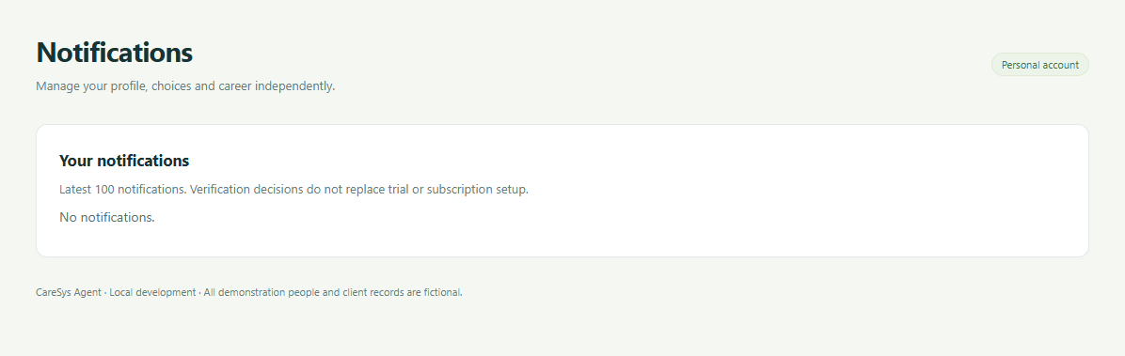
Screenshot 1 A new account starts with an empty inbox.
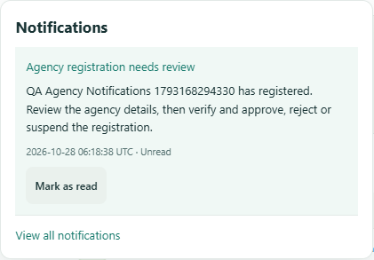
Screenshot 4 An active platform administrator receives a review request.

Registration form evidence
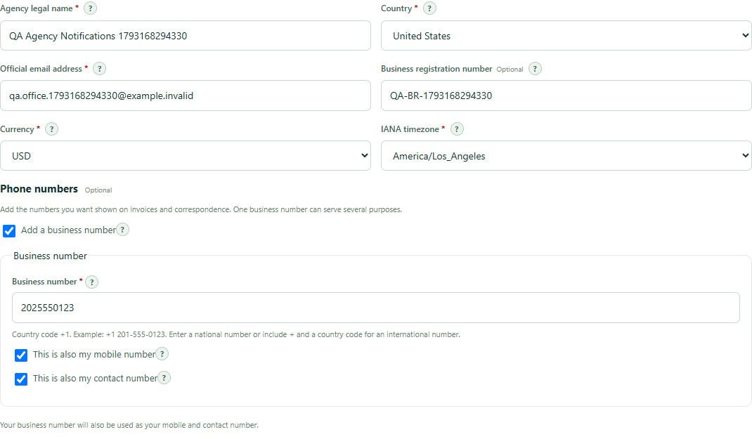
Screenshot 2 part 1 The same completed form is shown in two parts so its phone and address controls remain readable.

Registration form evidence continued
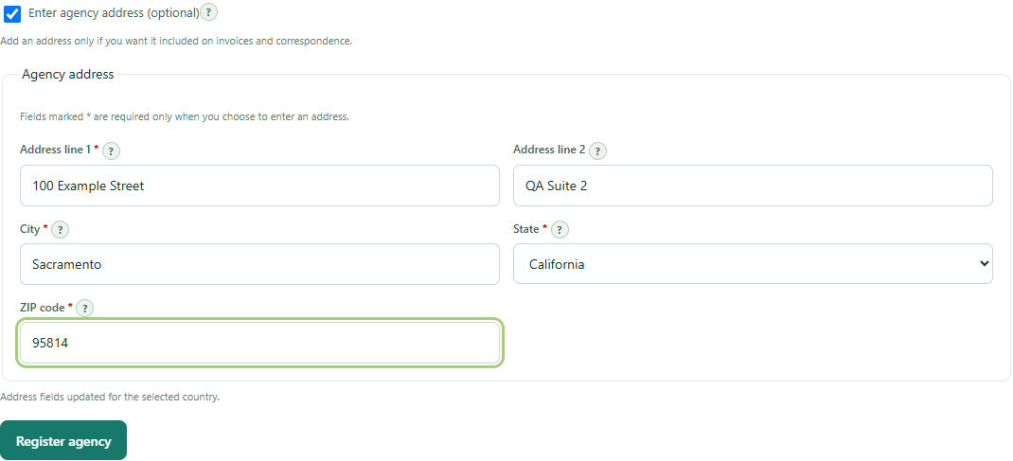
Screenshot 2 part 2 The same completed form is shown in two parts so its phone and address controls remain readable.

Registration receipt and billing evidence
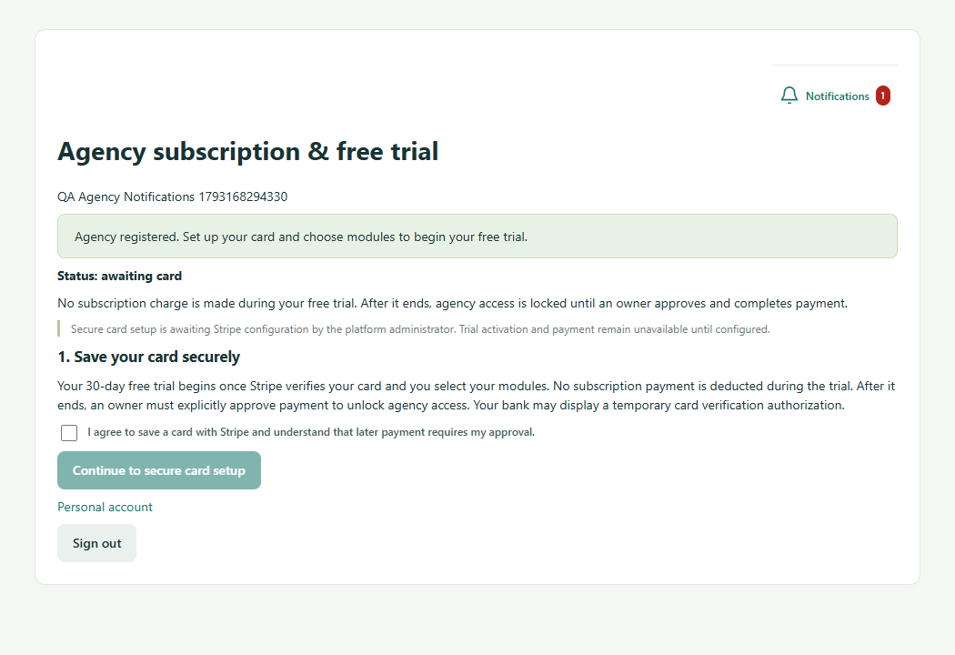
Screenshot 3 The receipt is available on the billing page while trial setup remains awaiting card.

Platform registration review evidence
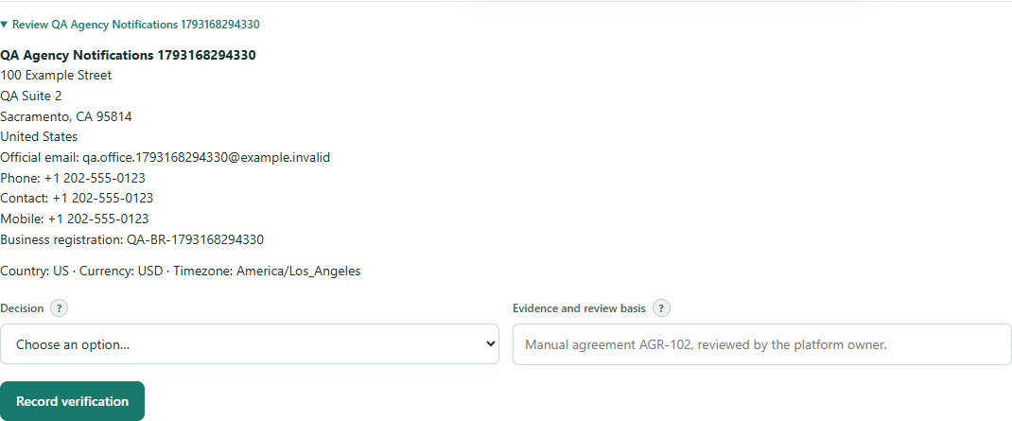
Screenshot 5 The administrator can inspect legal name, official contact details, address and the review decision form.

Verified and approved notification evidence
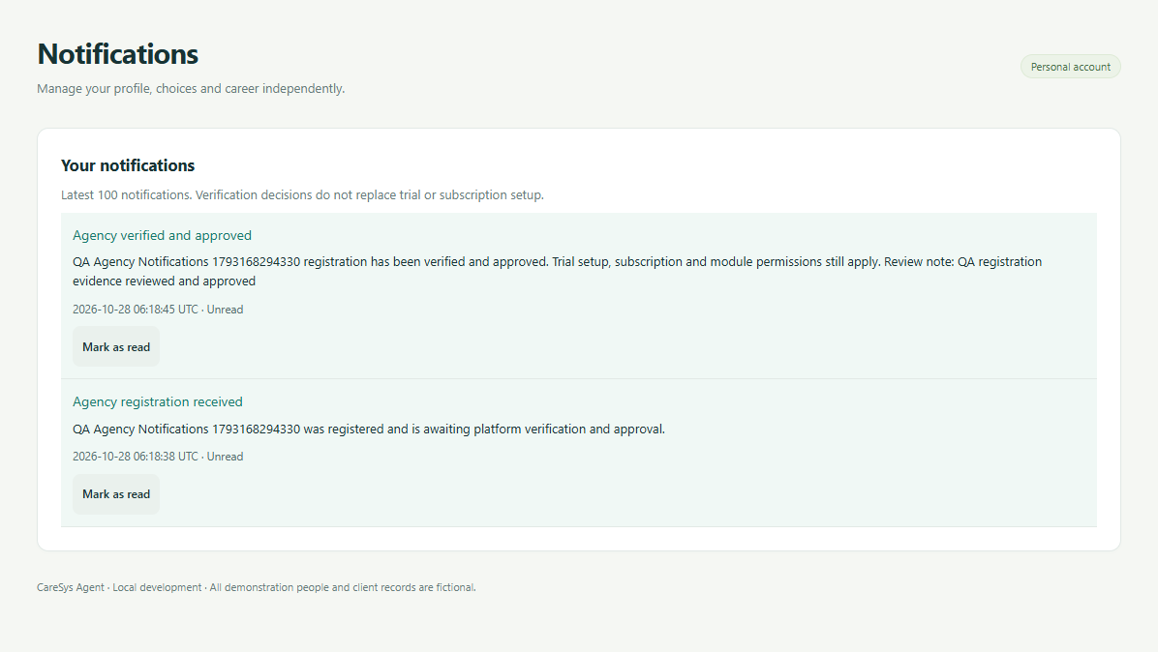
Screenshot 6 The owner receives the verified and approved decision and review note.

Rejected registration notification evidence
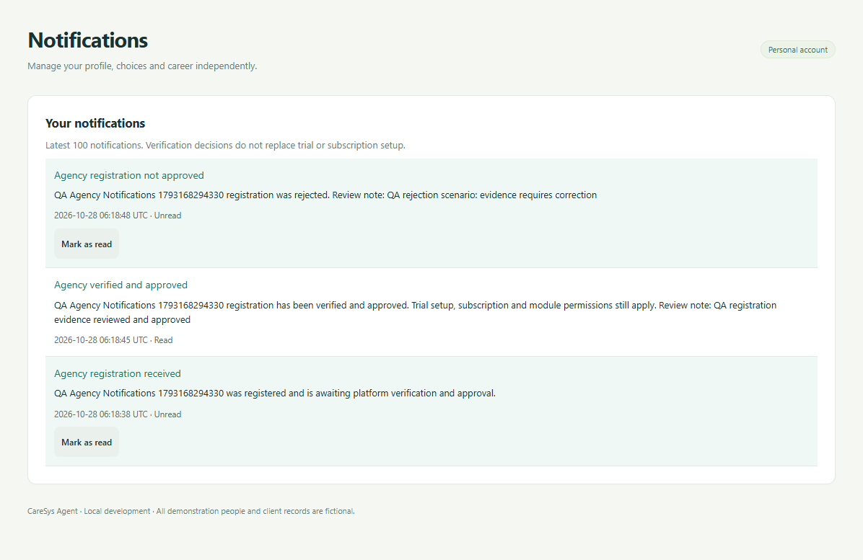
Screenshot 7 Rejection appears as its own notification while the earlier approval remains in the history.

Suspended registration notification evidence
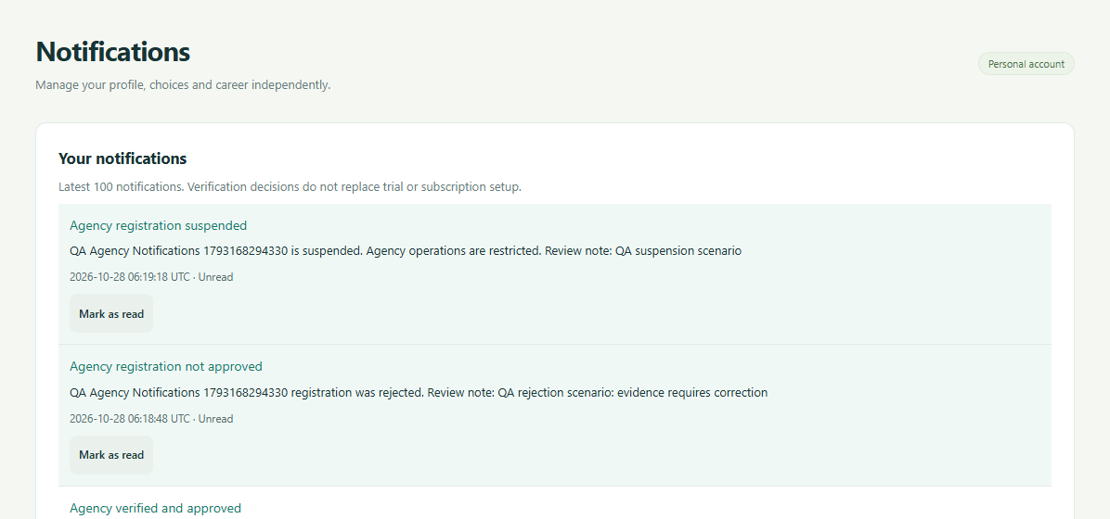
Screenshot 8 part 1 The suspension decision and earlier status history remain available in the personal inbox.

Suspended registration history evidence
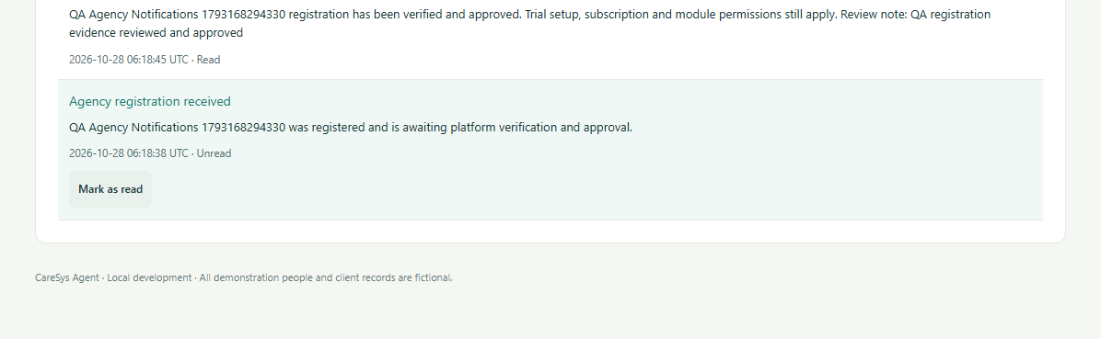
Screenshot 8 part 2 The suspension decision and earlier status history remain available in the personal inbox.

Mobile notification menu evidence
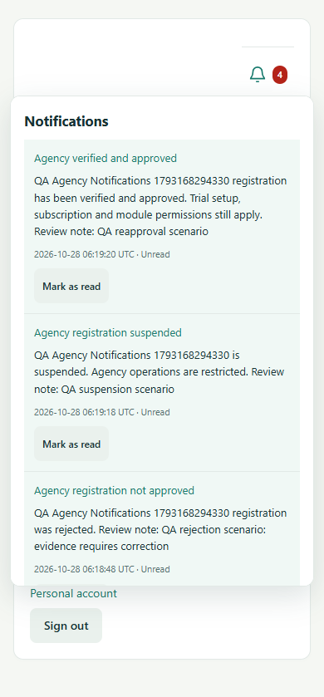
Screenshot 9 The mobile menu shows unread decisions and stays within the viewport.
All captured agency and account details are disposable fictional test data. The nine source screenshots remain in the screenshots folder. Two long captures are shown in cropped continuations without changing their contents.

